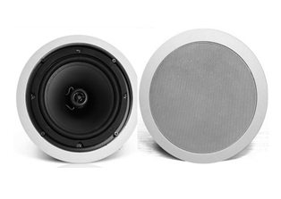
6" Coaxial Ceiling Speaker (7.5W-15W-30W)
FCS-630C
Feature:
- Commercial ceiling speaker with transformer
- Ideal for school, office, hotel and airport background music system
- Rated power output 7.5W-15W-30W at 100V
- 6" coaxial paper woofer and 1.5” tweeter
- Line input 100V or 70V
- ABS enclosure and metal grille in white
- Flush mount in-ceiling quick and secure installation

Specification：
Model | FCS-630C
Description | 6” Coaxial Ceiling Speaker
Rated Power Output | 7.5W/15W/30W
Line Input | 100V or 70V
Frequency Response | 110-18KHz
SPL(@1W/m) | 93dB
Speaker Unit | 6" coaxial paper woofer and 1.5” tweeter
Cutout Size | 195mm
Dimension | 230(D)×85(H)mm
Material | ABS enclosure and metal grille in white
Mounting Way | Flush mount in-ceiling quick and secure installation
Weight | 0.9kg
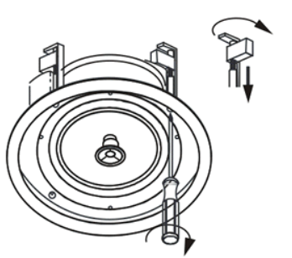
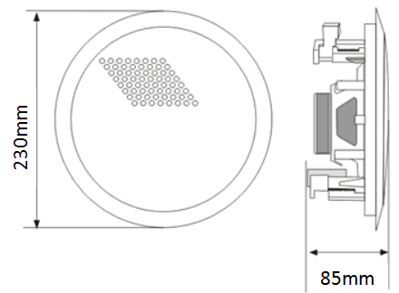
Dimension & Mounting:

Frequency Response & SPL Diagrams：
